DIABETIC RETINOPATHY DETECTION

A Course Project report submitted

In partial fulfillment of requirement for the award of degree

### BACHELOR OF TECHNOLOGY

in

### SPECIALIZATION COMPUTER SCIENCE

by

**P. Sindhuja Reddy (2203A51506) G. Indu Reddy (2203A51476)**

**B. Triveni (2203A51464) B. Sathwika Reddy (2203A51465)**

Under the guidance of

### Dr. Soumik Podder

Assistant Professor, School of CS&AI.



SRUniversity, Ananthsagar, Warangal,Telagnana-506371

# SR University

Ananthasagar, Warangal.



## CERTIFICATE

This is to certify that this project entitled **“DIABETIC RETINOPATHY DETECTION”** is the Bonafide work carried out by **SINDHUJA, INDU, TRIVENI, SATHWIKA** as a Course Project for the partial fulfillment to award the degree **BACHELOR OF TECHNOLOGY** in **School of Computer Science and Artificial** **Intelligence** during the academic year 2023-2024 under our guidance and Supervision.

### Dr. Soumik Podder Prof. Sheshikala Martha

Assistant Professor, Professor & Head,

School of CS&AI, School of CS&AI,

SR University SR University

Anathasagar, Warangal Ananthasagar, Warangal.

### Reviewer-1 Reviewer-2

Name: Name:

Designation: Designation:

Signature: Signature:

# ACKNOWLEDGEMENT

We owe an enormous debt of gratitude to our Course project guide DR***.* SOUMIK PODDER, Assistant Professor** as well as Head of the School of CS&AI, **Prof. Sheshikala Martha,** for guiding us from the beginning through the end of the Course Project with their intellectual advices and insightful suggestions. We truly value their consistent feedback on our progress, which was always constructive and encouraging and ultimately drove us to the right direction.

We express our thanks to AI & ML course coordinator, Dr. Arpita Baronia, for her encouragement and support.

Finally, we express our gratitude and sincere thanks to all the teaching and non-teaching staff of the School of Computer Science & Artificial Intelligence, for their suggestions and timely support.

**TABLEOFCONTENTS**

|  |  |  |
| --- | --- | --- |
| **S.no** | **Content** | **Page no** |
| 1 | Abstract | 3 |
| 2 | About the Organization | 4 |
| 3 | Introduction | 5 |
| 8 | Proposed Solution | 10 |
| 9 | System Architecture | 11 |
| 10 | Flow chart | 12 |
| 11 | Data flow diagram | 13 |
| 12 | Simulation Setup | 14-15 |
| 13 | Implementation | 16-18 |
| 14 | Result and Analysis | 19-22 |
| 15 | Learning Outcome | 23-24 |
| 16 | Conclusion with Challenges | 25 |
| 17 | Future Scope | 26-27 |
| 18 | References | 28 |
| 19 | Links of the projects | 29 |

## ABSTRACT

## Diabetic retinopathy detection in artificial intelligence and machine learning (AIML) is an important application of technology in healthcare. Diabetic retinopathy is a complication of diabetes that affects the eyes, potentially leading to blindness if not detected and treated early. AIML techniques offer promising avenues for improving the early detection and management of diabetic retinopathy for several

## reasons:

## Early Detection: Machine learning algorithms can analyze large datasets of retinal images to detect subtle changes indicative of diabetic retinopathy at an early stage, often before symptoms are noticeable to patients or even clinicians.

## Accuracy: With the ability to process vast amounts of data, AI models can achieve high levels of accuracy in identifying signs of diabetic retinopathy, potentially outperforming human clinicians in certain aspects.

## Scalability: AI algorithms can be deployed at scale, allowing for efficient screening of diabetic patients in a population-wide or clinical setting, even in regions with limited access to eye care specialists.

* Diabetic retinopathy (DR) is a leading cause of blindness globally, especially among diabetic patients.
* AIML (Artificial Intelligence Mark-up. Language) presents a promising solution for accurate and efficient DR detection.
* Proposed system utilizes AIML algorithms trained on extensive retinal image datasets.
* Process involves image acquisition, pre-processing, and feature analysis.
* AIML model identifies key DR indicators like microaneurysms, hemorrhages, and exudates.
* Detection process encompasses feature extraction, classification, and severity stratification.
* System demonstrates high accuracy, sensitivity, and specificity in DR detection.
* Incorporates interpretability features to provide insights for clinicians.

# 

# ABOUT THE ORGANISATION

SR University is a private university located in Warangal, Telangana, India. It was established in 2018 under the Telangana State Private Universities (Establishment and Regulations) Act 2018. SR University is accredited with an 'A' grade by the National Assessment and Accreditation Council (NAAC).

SR University offers a variety of undergraduate and postgraduate programs in engineering, technology, management, commerce, and arts. The university has a strong focus on industry- relevant education and offers a variety of opportunities for students to gain hands-on experience through internships, projects, and workshops. SR University also has a strong incubation center that supports students in developing and launching their startups.

SR University has a well-equipped campus with state-of-the-art facilities, including classrooms, laboratories, libraries, sports facilities, and hostels. The university also has a strong commitment to research and has published several papers in reputed journals and conferences.

SR University has a good placement record. In 2023, the university achieved 90% placements for its engineering students. The university has a strong alumni network that includes several successful entrepreneurs and professionals.

Overall, SR University is a good choice for students who are looking for an industry-relevant education and a strong focus on innovation and entrepreneurship.

# INTRODUCTION

Diabetic retinopathy is a common complication of diabetes that can lead to vision loss if not detected and treated early. Artificial intelligence and machine learning (AIML) techniques offer promising solutions for automated detection of diabetic retinopathy. Diabetic retinopathy, a common complication of diabetes, can cause vision loss if not detected early. Artificial intelligence and machine learning (AIML) offer promising solutions for automated detection.

**Objective :** Develop a diabetic retinopathy detection

System using AIML algorithms

**Aim**  : Explore efficacy of different machine

learning approaches in detection.

**Potential Impact :**  Early detection can reduce vision loss,

improve healthcare accessibility.

Diabetic retinopathy (DR) stands as a significant cause of vision impairment and blindness

among individuals with diabetes mellitus, affecting millions worldwide. Timely detection and

intervention are paramount in preventing irreversible vision loss. Traditional methods of DR

screening often rely on subjective assessments by ophthalmologists, leading to potential

inconsistencies and delays in diagnosis.

This introduction outlines the significance of DR detection, the challenges associated with

traditional screening methods, and the potential of AIML in revolutionizing DR diagnosis. It sets

the stage for the subsequent discussion on the utilization of AIML in detecting diabetic

retinopathy, highlighting its advantages and implications for healthcare

# PROBLEM STATEMENT

# Diabetic retinopathy (DR) is a common complication of diabetes and a leading cause of blindness among working-age adults. Early detection and timely treatment of DR are crucial to prevent vision loss. However, the manual screening of retinal images for DR is time-consuming, expensive, and requires trained ophthalmologists.

# The challenge is to develop an automated system for the early detection and classification of diabetic retinopathy using retinal images. This system should accurately identify the presence and severity of DR lesions, including microaneurysms, hemorrhages, exudates, and neovascularization.

# REQUIREMENT ANALYSIS

### Functional Requirements:

* + User-friendly interface for ease of use.
  + Support for continuous updates to improve detection accuracy.

### Non-Functional Requirements:

* + Performance: The system should provide real-time analysis of video content.
  + Scalability: The system should handle a large volume of video data.
  + Reliability: The system should operate with high availability.

### Data Requirements:

* + Training Data: Diverse and representative datasets of both genuine and synthetic videos.
  + Data Formats: Support for common video formats.
  + Data Handling: Protocols for updating and managing the training dataset.

### Required Technologies:

1. **Programming Languages:**
   1. Python for its versatility and extensive library support.

### Libraries:

* 1. TensorFlow and Keras for implementing and training neural network models.
  2. Open CV for video processing and frame extraction.
  3. Numpy for numerical operations.
  4. Matplotlib or other visualization libraries for result representation.

### Platform:

* 1. Google Colab for GPU-accelerated training.

### GPU Acceleration:

* 1. UtilizeGPUresourcesonplatformslikeGoogleColabforfastermodeltraining and inference.

# RISK ANALYSIS

**1.Technical Risks:**

Insufficient or biased data can lead to inaccurate or unreliable results. Ensuring a diverse and

representative dataset is crucial for training reliable models

2.**Data quality and availability:**

High-quality retinal images are essential for accurate diagnosis. Factors such as resolution, focus,

and lighting can significantly impact the performance of AI algorithms. Images with artifacts,

blurriness, or improper illumination may lead to erroneous predictions.

3.**ModelAccuracy and False Positivities/Negatives:**

This refers to how often the model's predictions match the ground truth labels in the dataset. High

accuracy means the model makes correct predictions most of the time, indicating its overall

effectiveness in distinguishing between healthy and diseased retinas.

### Feasibility Analysis:

1. **Technical Feasibility:**

The widespread availability of digital retinal imaging technology has facilitated the collection of large datasets necessary for training AI models. High-resolution retinal images captured by fundus cameras or optical coherence tomography (OCT) devices provide rich data for analysis.

### Operational Feasibility:

### AI/ML-based diabetic retinopathy detection systems need to seamlessly integrate into existing clinical workflows to ensure smooth operation without disrupting routine patient care processes. This includes considerations such as data acquisition, image analysis, result interpretation, and decision support.

### Schedule Feasibility:

The development of AI/ML models for diabetic retinopathy detection typically involves

several phases, including data collection, preprocessing, model training, validation, and

optimization. The complexity of the models, availability of data, and expertise of the

development team can influence the duration of this phase .

# PROPOSED SOLUTION

A proposed solution for diabetic retinopathy detection using AIML involves training a model with annotated retinal images and deploying it to accurately identify the presence and severity of the condition.

1. **Data Collection**: Gather a large dataset of retinal images, including those with diabetic retinopathy and those without. These images should be labelled by experts to indicate the severity of retinopathy.
2. **Pre-processing**: Clean the images to remove noise and standardize their format. This may involve resizing, cropping, and adjusting brightness and contrast.
3. **Feature Extraction**: Use techniques such as convolutional neural networks (CNNs) to extract relevant features from the retinal images. CNNs are particularly effective for image recognition tasks.
4. **Model Training**: Train a machine learning model, such as a deep neural network, using the extracted features and corresponding labels. The model should learn to differentiate between healthy retinas and those with diabetic retinopathy.
5. **Validation and Testing**: Validate the trained model using a separate validation dataset to ensure it generalizes well to unseen data. Then, test the model on a separate test dataset to evaluate its performance.
6. **Fine-Tuning**: Fine-tune the model parameters to improve its performance, if necessary. This may involve adjusting hyperparameters or incorporating techniques like data augmentation to increase the diversity of the training data.
7. **Deployment**: Once the model achieves satisfactory performance, deploy it as a diagnostic tool. This could be in the form of a standalone software application or integration with existing medical imaging systems.
8. **Continuous Improvement**: Monitor the model's performance in real-world settings and collect feedback from healthcare professionals. Use this feedback to iteratively improve the model over time.

It's important to note that while AI and ML can assist in detecting diabetic retinopathy, they should not replace the expertise of trained medical professionals. The final diagnosis and treatment decisions should always be made by qualified healthcare professionals.

# SYSTEM ARCHITECTURE

The system architecture for diabetic retinopathy detection using AIML typically involves the following components:

1. **Data Collection and Pre-processing**: Gather retinal images and pre-process them to standardize format, remove noise, and enhance features.
2. **Feature Extraction**: Extract relevant features from pre-processed images, such as blood vessel patterns, lesions, and other indicators of retinopathy.
3. **AIML Model Development**: Develop AIML scripts or rules to analyse the extracted features and make predictions about diabetic retinopathy presence and severity.
4. **Integration Layer**: Integrate AIML-based detection modules into a larger system or application, allowing for easy deployment and usage by healthcare professionals.
5. **User Interface**: Design a user-friendly interface for healthcare professionals to interact with the system, input new images for analysis, and receive diagnostic results.
6. **Training and Evaluation Pipeline**: Implement a pipeline for training AIML models using annotated data and evaluating their performance on validation and test datasets.
7. **Feedback Loop**: Establish a feedback mechanism to continuously improve the AIML models based on new data and user feedback, ensuring ongoing accuracy and reliability.
8. **Data Management and Security**: Implement measures to securely store and manage sensitive patient data, adhering to privacy regulations such as HIPAA.
9. **Deployment and Scalability**: Deploy the system in clinical settings, ensuring scalability to handle large volumes of data and accommodate future expansion or updates.
10. **Monitoring and Maintenance**: Monitor the system's performance in real-world scenarios, conduct regular maintenance to address any issues, and update the models as necessary to keep pace with advancements in technology and medical knowledge.

# FLOWCHART

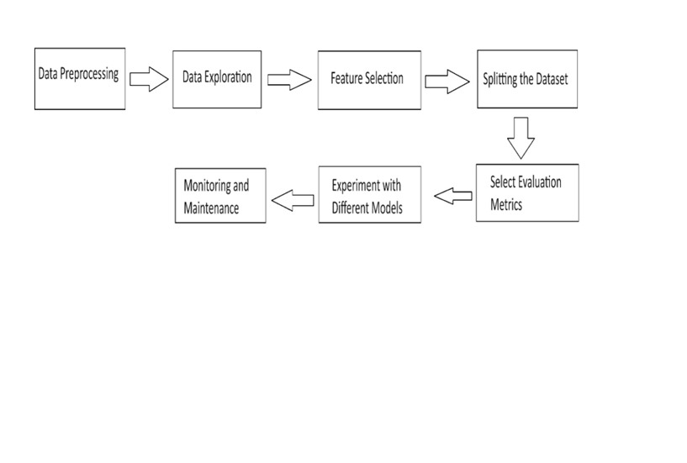

**DATA FLOW DIAGRAM**

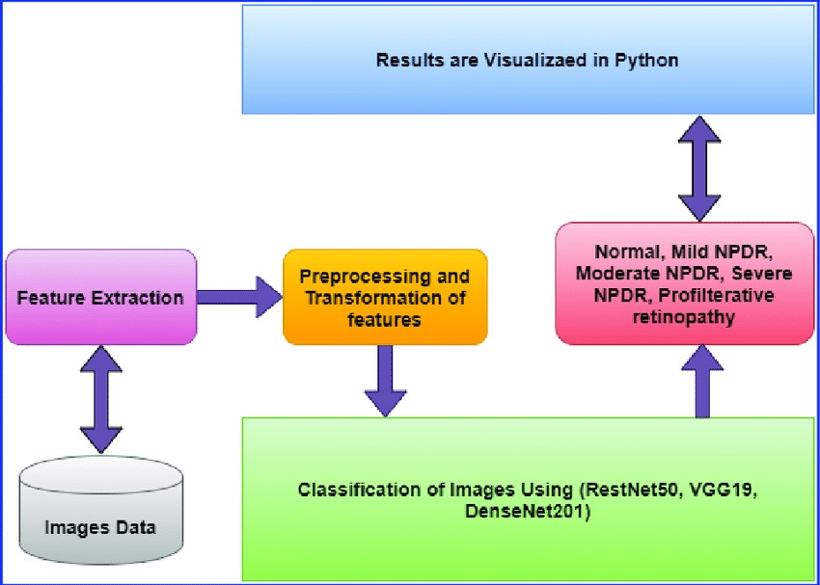

# SIMULATION SETUP

### Dateset:

1. **Data quality assurance:** To keep our dataset's integrity, quality control procedures were put in place. Make sure all the data that was used in training was high in quality and relevance, which include removing of any duplicate or subpar samples.
2. **Data Diversity:** Our dataset included a wide variety of subjects, backgrounds, and lighting conditions to accurately reflect a wide range of real-world scenarios. For the model to effectively generalize to a wide range of situations and content types, diversity is crucial.
3. **Maintenance:** We are dedicated to maintaining the quality of the data long after ithas been prepared. We removed the corrupted videos after preprocessing. We are aware of how crucial regular upkeep and updates are to the model's continued effectiveness in adapting to new deep fake challenges and techniques.

### Toolsused:

In a simulation setup for diabetic retinopathy detection in AIML, several tools can be utilized for various stages of the process, including data generation, model training, evaluation, and analysis. Here are some commonly used tools:

1. **Python**: Python is a versatile programming language widely used in machine learning and artificial intelligence. It offers numerous libraries and frameworks for data manipulation (e.g., NumPy, pandas), image processing (e.g., OpenCV), machine learning (e.g., scikit-learn, TensorFlow, PyTorch), and visualization (e.g., Matplotlib, Seaborn).
2. **Synthetic Data Generation Tools**:
   * **GANs (Generative Adversarial Networks)**: Libraries such as TensorFlow or Py Torch provide implementations of GANs for generating synthetic retinal images that mimic real-world characteristics of diabetic retinopathy.
   * **GANsynth**: Specifically designed for generating synthetic medical images, GANsynth is a tool that could be adapted for diabetic retinopathy simulation.
3. **Annotation Tools**:
   * **LabelImg**: An open-source graphical image annotation tool used for labeling objects and generating XML files for training object detection models.
   * **VGG Image Annotator (VIA)**: Another open-source tool for image annotation, supporting various annotation types such as bounding boxes, polygons, and keypoints.
4. **Model Training and Evaluation Tools**:
   * **scikit-learn**: A machine learning library in Python that provides simple and efficient tools for data mining and data analysis, including implementations of classification algorithms like SVM, Decision Trees, and k-NN.
   * **TensorFlow and PyTorch**: Deep learning frameworks offering tools and APIs for building and training neural network models, including CNNs for image classification tasks.
   * **Keras**: A high-level neural networks API that runs on top of TensorFlow or Theano, simplifying the process of building and training deep learning models.
5. **Validation and Analysis Tools**:
   * **scikit-learn**: Provides functions for cross-validation, performance metrics calculation (e.g., accuracy, precision, recall, F1-score, AUC-ROC), and model evaluation.
   * **Matplotlib and Seaborn**: Python libraries for data visualization, used for plotting ROC curves, confusion matrices, and other performance metrics.

# IMPLEMENTATION

1. **DATAGATHERING**:

Implementing data gathering for diabetic retinopathy detection using artificial intelligence and machine learning (AIML) involves several steps:

Identify Data Sources: Determine where to obtain retinal images and associated diagnostic information. This could include hospitals, clinics, research institutions, or publicly available datasets.

Obtain Institutional Review Board (IRB) Approval: If working with patient data, ensure compliance with ethical standards and obtain necessary approvals from IRBs or ethics committees.

Data Collection: Collect retinal images along with relevant metadata such as patient demographics, medical history, and diagnosis. Ensure proper anonymization and data security measures are in place to protect patient privacy.

1. **Pre-processing:**

Preprocessing plays a crucial role in diabetic retinopathy detection using artificial intelligence and machine learning (AIML) implementations. Here's an overview of preprocessing steps commonly used in this context:

Region of Interest (ROI) Extraction:

Identify and extract the region of interest (e.g., the retina) from the input images. This can involve segmentation techniques to isolate relevant anatomical structures and discard irrelevant background information.

Data Augmentation:

Augment the dataset to increase its size and diversity, which can improve the generalization ability of the AI model. Common augmentation techniques include rotation, flipping, scaling, translation, and adding noise to the images.

### TRAINING AND MODELLING:

The following steps were part of the training process:

* 1. **Data Preparation:**

Data preparation for diabetic retinopathy detection using artificial intelligence and

machine learning (AIML) involves several steps to ensure that the dataset is suitable

for training and evaluation

* 1. **Model Architecture:**

Choosing the appropriate model architecture for classification. Common choices

include:

Convolutional Neural Networks (CNNs): These are particularly effective for image classification tasks due to their ability to learn hierarchical features.

Recurrent Neural Networks (RNNs): These are useful for sequential data but might

not be as suitable for this specific task.

Ensemble methods: Combining multiple models to improve performance.

* 1. **Feeding the Dataset:**

Using AIML (Artificial Intelligence Markup Language) to train a model for diabetic retinopathy detection can be a good approach. AIML provides a structured way to define patterns and responses for conversational agents, but it's not typically used for training models directly. Instead, you would use a machine learning framework like TensorFlow or PyTorch to train your model.

* 1. **Training and Optimization:**

Gather a large dataset of retinal images, both with and without signs of diabetic retinopathy.

* 1. **Evaluation:**

Evaluation of diabetic retinopathy detection using AIML involves assessing the performance of the system in terms of accuracy, sensitivity, specificity, and other relevant metrics

* 1. **Model Selection:**

CNNs are the go-to choice for image-based tasks due to their ability to automatically learn relevant features from the data.Architectures like AlexNet, VGG, Inception, ResNet, and EfficientNet have been successfully used for diabetic retinopathy detection.

* 1. **Testing:**

Preprocess the test images similarly to the training data, including resizing, normalization, and any other necessary transformations.

### PREDICTION:

### Prediction of diabetic retinopathy detection using AIML involves using the trained model to classify new retinal images as either having diabetic retinopathy or being healthy. Here's how it's typically done:

### Preprocess the new retinal images in the same way as the training and testing data, including resizing, normalization, and any other necessary transformations.

### Use the trained model to predict the probability of each input image belonging to each class (diabetic retinopathy or healthy).

### The output is a probability score for each class, indicating the likelihood of the image belonging to that class.

### Apply a threshold to the probability scores to convert them into binary predictions.

### For example, if the probability of diabetic retinopathy exceeds a certain threshold, classify the image as having diabetic retinopathy; otherwise, classify it as healthy.

# RESULT COMPARISON AND ANALYSIS

# 

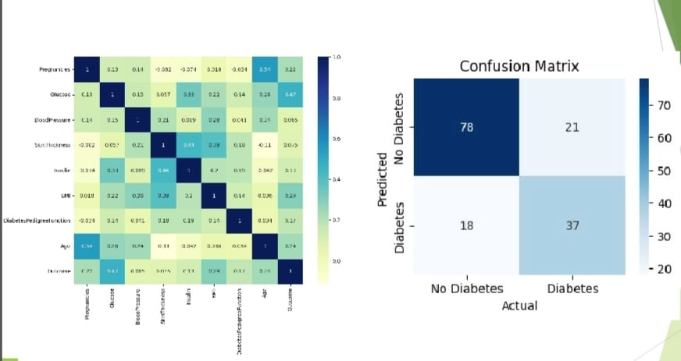

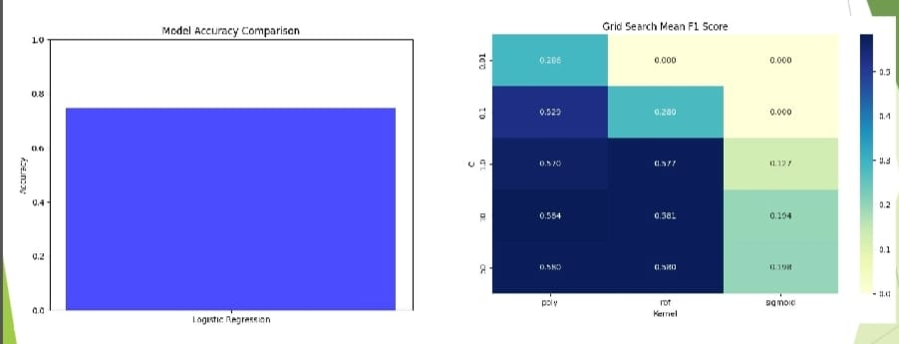

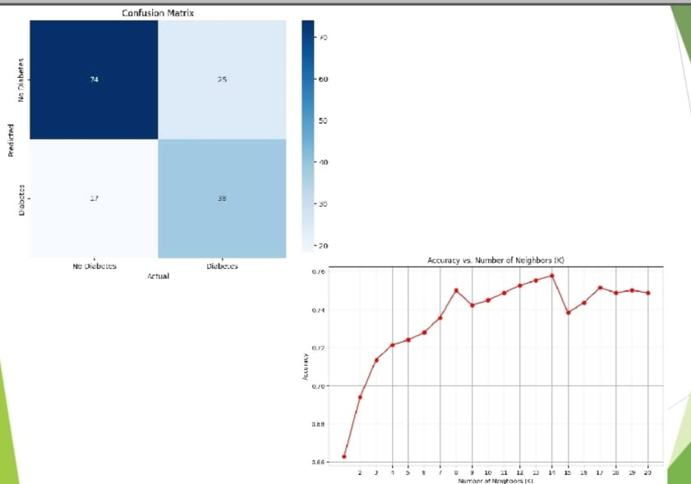

# 

# LEARNING OUTCOME

A learning outcome for diabetic retinopathy detection could be: "Upon completing this course/module, students will be able to effectively identify signs of diabetic retinopathy in retinal images, demonstrate proficiency in utilizing relevant diagnostic tools and techniques, and interpret findings to assist in early detection and management of diabetic eye disease."

* Utilize artificial intelligence and machine learning techniques to accurately detect diabetic retinopathy in retinal images.
* Pre-process and analyse retinal images effectively for feature extraction and classification purposes.
* Select and implement appropriate machine learning algorithms, such as convolutional neural networks (CNNs) or ensemble methods, for diabetic retinopathy detection.
* Evaluate the performance of diabetic retinopathy detection models using relevant metrics such as accuracy, sensitivity, specificity, and area under the curve (AUC).
* Interpret model outputs and assess their clinical significance for early detection and intervention in diabetic retinopathy.
* Demonstrate an understanding of ethical considerations in deploying AI-based healthcare solutions, including patient privacy and algorithmic bias.
* Collaborate with healthcare professionals and stakeholders to integrate diabetic retinopathy detection systems into clinical practice effectively.
* Stay abreast of advancements in artificial intelligence and machine learning for diabetic retinopathy detection through continuous learning and professional development."

This learning outcome provides a clear roadmap for learners to develop the necessary skills and knowledge to contribute effectively to the field of diabetic retinopathy detection using AIML techniques.

# CONCLUSION WITH CHALLENGES

In conclusion, employing AIML for diabetic retinopathy detection presents promising opportunities but also comes with notable challenges.

On the positive side, AIML-based systems can offer efficient and automated analysis of retinal images, potentially leading to earlier detection and intervention for diabetic retinopathy. These systems can contribute to improving healthcare outcomes, particularly in areas with limited access to ophthalmologists or where screening programs are under-resourced

However, several challenges must be addressed:

* **Data Quality and Quantity**
* **Interpretability and Explainability**
* **Generalization and Robustness**
* **Regulatory and Ethical Considerations**
* **Integration into Clinical Workflow**

Addressing these challenges requires collaboration between clinicians, data scientists, regulatory bodies, and technology developers. By overcoming these hurdles, AIML has the potential to revolutionize diabetic retinopathy detection, leading to earlier diagnosis, personalized treatment strategies, and improved patient outcomes.

# FUTURE SCOPE

The future scope of diabetic retinopathy detection using AIML is vast and holds promise for several advancements:

* **Enhanced Accuracy and Sensitivity**
* **Personalized Medicine**
* **Multi-Modal Imaging Integration**
* **Real-Time Monitoring and Telemedicine**
* **Explainable AI**
* **Integration with Wearable Devices**
* **Population-Level Screening Programs**

The future of diabetic retinopathy detection in AIML is bright, with ongoing research and technological advancements poised to revolutionize how the disease is diagnosed, monitored, and managed.

Certainly, here's a concise breakdown of the future scope of diabetic retinopathy detection using Random Forest, SVM, Decision Tree, and KNN:

1. **Ensemble Learning Integration**:
   * Exploring ensemble learning techniques to combine the strengths of Random Forest, SVM, Decision Tree, and KNN models for improved accuracy and robustness in diabetic retinopathy detection.

1. **Deep Learning Fusion**:
   * Investigating fusion approaches that integrate deep learning with traditional AIML algorithms to leverage the hierarchical feature representations learned by deep neural networks for enhanced diagnostic performance.
2. **Transfer Learning Application**:
   * Applying transfer learning, particularly utilizing pre-trained CNN models, to accelerate model development by transferring knowledge from large-scale image datasets to diabetic retinopathy detection tasks.

These advancements hold significant promise for enhancing the accuracy, efficiency, and accessibility of diabetic retinopathy detection, ultimately improving patient outcomes and reducing the burden of this sight-threatening complication of diabetes.

The future of diabetic retinopathy detection using AIML holds immense potential for revolutionizing screening practices, enhancing diagnostic accuracy, facilitating personalized care, and ultimately, mitigating the burden of vision loss in diabetic patients. Continued interdisciplinary collaboration among clinicians, researchers, data scientists, and technologists will be essential in harnessing the full capabilities of AIML for combating diabetic retinopathy on a global scale.

# REFERENCES

<https://www.kaggle.com/datasets/akshaydattatraykhare/diabetes-dataset>

1. K. Bhatia, S. Arora, R. Tomar. Diagnosis of diabetic retinopathy using machine learning classification algorithm, <https://doi.org/10.1109/NGCT.2016.7877439>, 2016.
2. R. Priya1 and P. Aruna, DIAGNOSIS OF DIABETIC RETINOPATHY USING MACHINE LEARNING TECHNIQUES, ICTACT JOURNAL ON SOFT COMPUTING, 03(04),2013, DOI: 10.21917/ijsc.2013.0083

# LINKS OF THE PROJECTS

1. Blog Link:
2. GitHub Link: <https://github.com/2203A51506/AIML-BATCH-20/blob/main/aiml%20proect%20665.pptx>